PO Box 579, Muscat. PC 113
Sultanate of Oman

Tel: (968) 244 84 292
Fax: (968) 244 83 039
e-mail: Renardet-oman@renardet.net

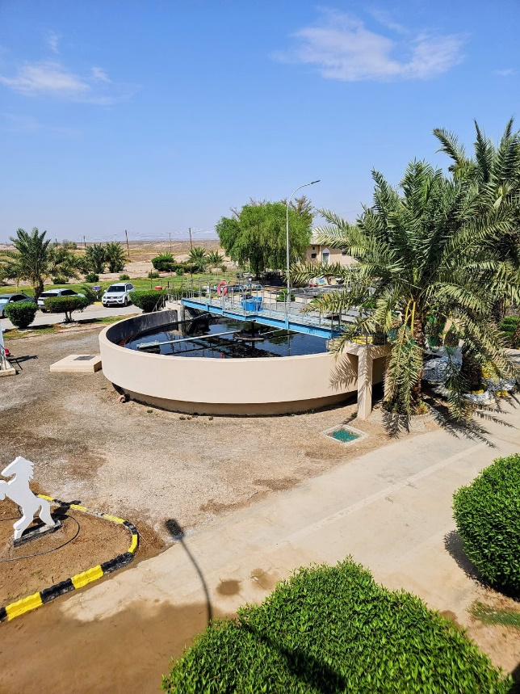
Tender No. T/2719110/2025

Consultancy Services for Design and Supervision for STP, Sewer & TE Networks Systems in Ibri

Inception Report
REPORT QUALITY TABLE
Project Name | Consultancy Services for Design and Supervision for STP, Sewer & TE Networks Systems in Ibri
Title of the Report | Inception Report
Issued by | Hossein Forouzan
Checked by
Status | Draft report

Rev. | Date | Description
0 | AUG 2026 | First issue - Draft

Previously Submitted Reports
Ref Number | Title | Nature | Version | Issued by | Date of submission

Table of Contents
1. Introduction 6
2. Project Background and Objectives 7
3. Project Area 8
4. Understanding of the Scope 10
4.1 Data Collection and Validation 10
4.2 Surveys and Field Investigations 10
4.3 Existing System Assessment 11
4.4 Concept Design 11
4.5 Preliminary Design 12
4.6 Detailed Design 13
4.7 Tender Documentation and Tendering Support 13
4.8 Post-Award Support and Construction Supervision 14
4.9 General Design Responsibilities 14
5. Existing Information and Preliminary Findings 15
5.1 Existing Sewage Treatment Plant 15
5.2 Existing Sewer Network 16
5.3 Preliminary Findings 17
6. Design Basis and Applicable Standards 18
6.1 General Design Basis 18
6.2 Design Horizon 19
6.3 Population and Wastewater Flow Basis 20
6.4 Wastewater Collection System 22
6.5 Sewage Lifting Stations and Rising Mains 23
6.6 Sewage Treatment Plant 24
6.7 Treated Effluent System 24
6.8 Hydraulic Modelling 25
6.9 Applicable NWS Documents 26
6.10 Other Applicable Standards and Regulations 26
7. Mobilisation Activities 27
8. Data Collection and Validation 28
9. Surveys and Field Investigations 28
10. Stakeholder, NOC and Authority Coordination 28
11. Deliverables and Submission Strategy 29
12. Project Programme 29
12.1 Concept Design Stage 30
12.2 Preliminary Design Stage 30
12.3 Detailed Design Stage 31
12.4 Tender Documents Stage 31
13. Project Organization and Team Arrangement 32
13.1 JV Project Coordination 32
13.2 JV Quality Control Team 32
13.3 Discipline Coordination 33
13.4 Project Team Contact List 33
14. HSE Requirements & Plan 36
15. Quality Requirements & Plan 36
16. Scope of Work for Topographic, Existing Utility Survey and GIS Data Collection 38
16.1 Existing Utility Survey and Detailed Topographic Survey (Approx. 20 km²): 38
16.2 Detailed Topographic Survey (Approx. 450 km²) 38
16.3 Objectives 39
16.4 Scope of Work (SoW) Project – 1 39
16.4.1 Existing Utilities Field Data Collection and GIS integration 39
16.4.2 Wastewater (WW) / Sewer System 39
16.4.3 Wastewater (WW) / Sewer System 40
16.4.4 Sewage Treatment Plant (STP) 41
16.5 Scope of Work (SoW) Project – 2 42
16.5.1 Detailed Topographic Survey 42

Table of Tables
Table 1 Villages and Settlements within the Project Area 9
Table 2- Preliminary Population Projection by Village 20
Table 3-Preliminary Wastewater Generation by Village 21
Table 4 Project Activity Schedule 31
Table 5 Project Team Contact List 36
Table 6 GIS Database Layers - WW 40
Table 7 GIS database layers - TE 41
Table 8 GIS database layers - STP 42

Table of Figures
Figure 1 Project Location and Village Boundaries 8
Figure 2 Existing Ibri Sewage Treatment Plant 16
Figure 3 Existing Ibri Sewer Treatment Plant 17
Figure 4 Project Organization Chart 36
Figure 5 Project Location Map 39
Abbreviations and Acronyms
Shortcut | Full Form
cu.m | Cubic meter
DI | Ductile Iron (pipe material)
DN | Diametre Nominale (Nominal diameter)
l/s | Liters per Second
m | meter
VFD | Variable Frequency Drive
LCD | liters per capita per day
M&E | Mechanical and Electrical
MOHUP | Ministry of Housing and Urban Planning,
MLD | Million Liters per Day
Hr | hour
PS | Pump Station
BPS | Booster Pumping Station
SR | Service Reservoir
IR | Intermediate Reservoir
GR | Ground Reservoir
TFS | Tanker Filling Station
NWS | Oman Water & Wastewater Services Company
NWS | Nama Water Services
PAW | Public Authority for Water (Diam)
RO | Rial’s Omani
DP | Desalination Plant
dia | Diameter
ET | Elevated Tank
APD | Asset Planning Department
APSR | Authority for Public Services Regulation

- Introduction
Nama Water Services Company SAOC (NWS) has appointed Renardet S.A. & Partners Consulting Engineers to provide consultancy services for the design and supervision of the sewage treatment plant, sewerage network and treated effluent network systems in Ibri Wilayat under Tender No. T/2719110/2025.
The project is intended to expand wastewater and treated effluent services within the defined project boundary, serve existing and future developments, review and integrate the existing infrastructure, and develop suitable long-term solutions for wastewater collection, treatment and treated effluent reuse.
The consultancy services generally comprise:
- data collection and validation;
- field surveys and investigations;
- assessment of existing sewerage, pumping, treatment and treated effluent assets;
- concept, preliminary and detailed design;
- hydraulic modelling of the sewer and treated effluent systems;
- sewage treatment plant planning and design;
- preparation of tender documents and assistance during tendering;
- post-award design support; and
- construction supervision services.
The project shall be developed in accordance with the approved Terms of Reference, applicable NWS guidelines, specifications, standard drawings and procedures. The principal design guidelines include PAM-GUD-201, PAM-GUD-202 and PAM-GUD-203, covering general design requirements, potable water and treated effluent systems, and wastewater systems respectively.
The preliminary desktop assessment indicates that the Ibri project area is generally favorable for gravity sewerage, due to the overall terrain falling towards the existing Ibri STP location. However, some low-lying and remote areas may require sewage lifting stations, rising mains, alternative routing or decentralized treatment solutions. These preliminary findings remain subject to confirmation through field surveys, verified asset information, flow data, geotechnical investigation and hydraulic modelling.
This Inception Report has been prepared during the mobilisation stage to present the Consultant’s initial understanding of the project, proposed methodology, mobilisation arrangements, data requirements, field investigation strategy, project organisation, programme, deliverables, quality procedures, HSE requirements and key project risks.
The report also identifies the immediate information and decisions required from NWS and other relevant authorities to enable the Consultant to proceed efficiently with the concept design stage. It is intended to establish a common basis between NWS and the Consultant regarding the project scope, priorities, responsibilities and planned sequence of activities.

- Project Background and Objectives
Nama Water Services intends to improve and extend the wastewater collection, treatment and treated effluent systems within Ibri Wilayat. The project will serve existing developed areas, vacant plots, areas under construction and future developments within the approved project boundary.
The existing wastewater infrastructure does not provide full coverage of the study area. Accordingly, the project requires the review of the existing systems, confirmation of their condition and capacity, and development of an integrated long-term solution for sewage collection, treatment and treated effluent reuse.
The project includes the planning and design of:
- property and house connections;
- tertiary, secondary and trunk sewer networks;
- sewage lifting and pumping stations;
- rising mains;
- sewage treatment capacity;
- treated effluent transmission and distribution networks;
- treated effluent pumping and storage facilities;
- tanker discharge and filling facilities;
- sludge handling and disposal arrangements; and
- associated civil, structural, mechanical, electrical, instrumentation and control works.
The main objectives of the project are to:
- provide wastewater services to all eligible plots within the project area;
- maximise gravity conveyance and minimise the number of pumping stations;
- assess and integrate the existing sewer, pumping, STP and treated effluent assets;
- determine reliable wastewater flows for the required design horizons;
- identify suitable locations and phased capacities for sewage treatment facilities;
- develop an efficient treated effluent reuse and distribution strategy;
- reduce operational energy consumption and whole-life cost;
- ensure safe, reliable and maintainable infrastructure;
- address odour, hydrogen sulphide, flooding, groundwater and environmental risks;
- secure the required lands, routes, NOCs and authority approvals;
- develop technically and economically justified design alternatives; and
- prepare complete designs and tender documents suitable for implementation.
The design shall consider current requirements, future growth and ultimate development conditions. The system shall be planned in phases so that infrastructure can be implemented in accordance with actual population growth, development priorities, available treatment capacity and NWS investment plans.
A preliminary desktop assessment indicates that most of the central Ibri area may be suitable for gravity sewerage towards the existing STP location. However, this finding requires confirmation through topographical survey, verification of existing assets, population and flow assessment, geotechnical investigation and hydraulic modelling. Low-lying and remote areas will be assessed through alternative routing, lifting stations, long-distance conveyance or local treatment options.
- Project Area
The project area covers Ibri and the surrounding settlements included within the proposed sewerage, STP and treated effluent service boundary. The overall project boundary is shown in Figure 1.
The project area has been divided into individual village and settlement zones for population assessment, wastewater-flow estimation, catchment planning and hydraulic modelling. The outer project boundary also includes undeveloped areas that may be required for future infrastructure corridors, treatment facilities and network expansion.
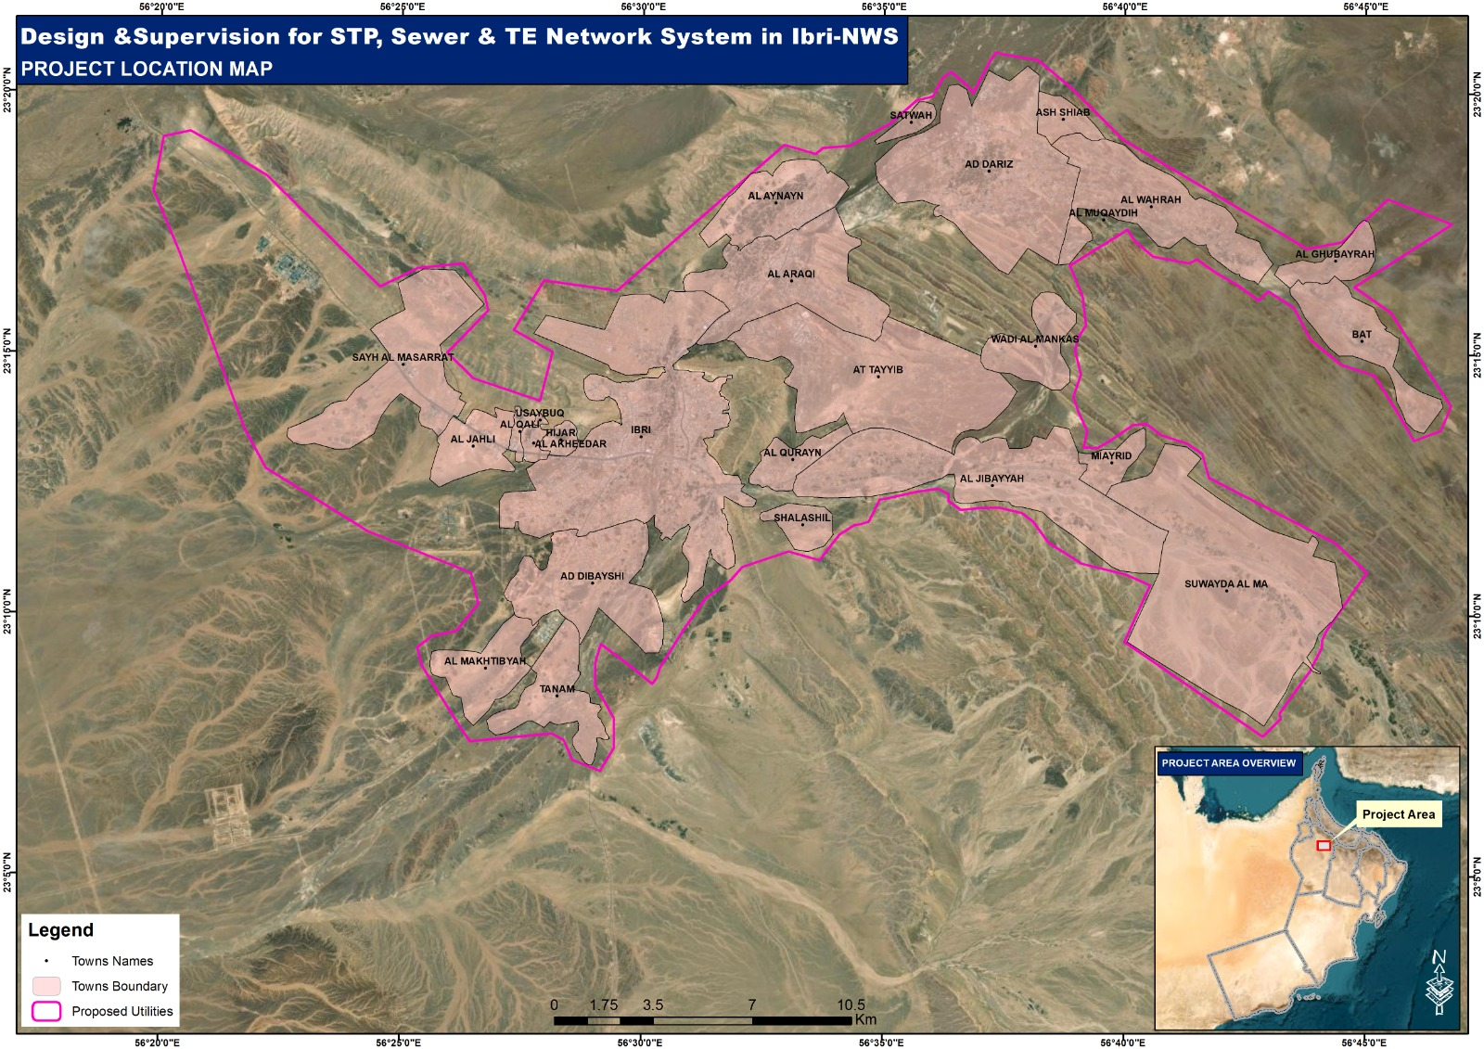
Figure 1 Project Location and Village Boundaries

No. | Village / Settlement
1 | Ad Dariz
2 | Ad Dibayshi
3 | Al Akheedar
4 | Al Araqi
5 | Al Aynayn
6 | Al Ghubayrah
7 | Al Jahli
8 | Al Jibayyah
9 | Al Makhtibyah
10 | Al Qali
11 | Al Qurayn
12 | Al Wahrah
13 | Ash Shiab
14 | At Tayyib
15 | Bat
16 | Hijar
17 | Ibri
18 | Miayrid
19 | Satwah
20 | Sayh Al Masarrat
21 | Shalashil
22 | Suwayda Al Ma
23 | Tanam
24 | Usaybuq
25 | Wadi Al Mankas
Table 1 Villages and Settlements within the Project Area
The village boundaries shown on the project location map will be used as the preliminary basis for allocating population and wastewater flows. These boundaries will be reviewed during the design stage against updated land-use plans, cadastral information, existing development, topographic conditions and the approved project boundary.

- Understanding of the Scope
The Consultant understands that the assignment covers the complete development of wastewater collection, sewage treatment and treated effluent systems within the defined Ibri project area, from initial data collection through design, tendering support and construction supervision.
The services shall be carried out in coordinated stages, with each stage developed based on approved information, verified field data and NWS instructions.
  - Data Collection and Validation
The Consultant shall collect, review and validate all available information relevant to the project, including:
- previous studies and master plans;
- existing sewer and treated effluent network drawings;
- GIS and asset records;
- existing STP and pumping station information;
- population and land-use data;
- water-consumption and wastewater-flow records;
- existing customer and house-connection information;
- utility records;
- topographical and geotechnical information;
- environmental and flood-related data; and
- applicable NWS standards, specifications and drawings.
Any inconsistency, missing information or unverified data shall be recorded and raised with NWS for clarification.
  - Surveys and Field Investigations
The Consultant shall undertake the required field studies to establish a reliable design basis. These activities include:
- topographical survey;
- verification of existing sewer and treated effluent assets;
- manhole, chamber and pumping station inspections;
- CCTV and condition surveys where required;
- underground utility detection;
- trial pits at critical locations;
- geotechnical investigations;
- groundwater assessment;
- site reconnaissance;
- survey of potential STP, pumping station and reservoir sites; and
- identification of existing and future customer connections.
The survey information shall be incorporated into the project GIS and used as the common base for all design disciplines.
  - Existing System Assessment
The existing wastewater, pumping, treatment and treated effluent systems shall be reviewed to determine:
- existing capacity;
- present operating condition;
- hydraulic performance;
- structural and mechanical condition;
- available spare capacity;
- operational limitations;
- requirements for rehabilitation or replacement;
- potential for integration into the proposed system; and
- future expansion requirements.
The Consultant shall coordinate with NWS operation and maintenance personnel to obtain practical information on system performance, recurrent problems and operational constraints.
  - Concept Design
The concept design stage shall establish the preferred overall strategy for the project.
The Consultant shall develop and compare alternative solutions for:
- sewer catchments and flow directions;
- trunk sewer routes;
- gravity and pumped conveyance;
- sewage lifting and pumping stations;
- rising mains;
- STP location, process and phasing;
- treated effluent storage, pumping and distribution;
- tanker discharge facilities;
- treated effluent filling facilities;
- sludge management;
- emergency storage and overflow arrangements; and
- implementation and contract packaging.
A minimum of three technically feasible alternatives shall be considered for the main wastewater, treated effluent and STP components where required.
The alternatives shall be evaluated based on:
- technical feasibility;
- hydraulic performance;
- land requirements;
- constructability;
- operation and maintenance;
- energy consumption;
- environmental and social impacts;
- authority approvals;
- capital cost;
- operating cost;
- whole-life cost; and
- project risks.
  - Preliminary Design
Following approval of the preferred concept, the preliminary design shall develop the selected solution to a level sufficient to confirm the main system configuration, capacities, locations and performance requirements.
The preliminary design shall include:
- updated hydraulic models;
- preliminary layouts and profiles;
- preliminary equipment sizing;
- pumping station and STP process arrangements;
- structural and architectural concepts;
- electrical and instrumentation requirements;
- preliminary land and utility requirements;
- preliminary quantities and cost estimates;
- design risk assessment;
- environmental requirements; and
- updated implementation programme.
  - Detailed Design
The detailed design shall provide complete coordinated documents suitable for construction and tendering.
The detailed design shall include:
- final hydraulic calculations and models;
- detailed sewer and treated effluent layouts and profiles;
- house-connection details;
- pumping station and rising-main design;
- STP process, civil, structural and MEP design;
- surge analysis and protection where required;
- instrumentation, control and SCADA design;
- utility diversions and crossing details;
- road and wadi crossing details;
- material and equipment specifications;
- construction drawings;
- bills of quantities;
- cost estimates;
- testing and commissioning requirements; and
- operation and maintenance considerations.
  - Tender Documentation and Tendering Support
The Consultant shall prepare the required tender documents based on the approved design, including:
- conditions and technical requirements;
- drawings;
- specifications;
- bills of quantities;
- schedules;
- design criteria;
- testing and commissioning requirements; and
- contractor submission requirements.
During tendering, the Consultant shall support NWS through:
- responses to tender queries;
- issue of clarifications and addenda;
- participation in pre-tender meetings and site visits;
- technical evaluation;
- commercial review where required;
- tender recommendation; and
- preparation of final contract documents.
  - Post-Award Support and Construction Supervision
Following award of the construction contract, the Consultant shall provide design support and supervision services as instructed by NWS.
These services may include:
- review of contractor submissions;
- review of shop drawings and method statements;
- clarification of design requirements;
- inspection of construction works;
- verification of materials and equipment;
- monitoring of quality, safety and progress;
- witnessing of testing and commissioning;
- review of as-built drawings;
- review of operation and maintenance manuals;
- support during handover; and
- resolution of design-related issues during construction.
  - General Design Responsibilities
Throughout all stages, the Consultant shall ensure that the proposed systems are:
- fit for purpose;
- safe and reliable;
- hydraulically adequate;
- constructable;
- maintainable;
- energy efficient;
- environmentally acceptable;
- compatible with existing NWS infrastructure;
- suitable for phased implementation; and
- compliant with the applicable NWS requirements and authority approvals.

- Existing Information and Preliminary Findings
  - Existing Sewage Treatment Plant
A site visit was carried out to the existing Ibri Sewage Treatment Plant to review the current facilities, operating condition and available treatment capacity.
The existing STP was constructed in 2006 with a nominal treatment capacity of approximately 1,800 m³/day. A package treatment plant with a capacity of approximately 500 m³/day was subsequently added as an extension to increase the overall treatment capacity.
Accordingly, the combined nominal treatment capacity of the existing facilities is approximately 2,300 m³/day.
Based on the information obtained during the site visit, the plant currently receives approximately:
- 1,100 m³/day from the existing sewer network; and
- 1,200 m³/day from yellow tankers.
The total current inflow is therefore approximately 2,300 m³/day, which is equal to the combined nominal capacity of the existing STP and package plant.
This indicates that the existing treatment facilities are operating at or close to their available capacity, with limited allowance for future increases in sewered flow, tanker discharge, operational variation or emergency conditions.
The existing facilities shall therefore be assessed in greater detail during the concept design stage, including:
- confirmation of the actual treatment capacity of each process unit;
- review of current and historical inflow records;
- assessment of peak and seasonal flows;
- review of influent and treated effluent quality;
- assessment of process performance and operational limitations;
- condition assessment of civil, mechanical, electrical and control systems;
- review of sludge handling and disposal arrangements;
- assessment of the package plant performance;
- confirmation of available land for expansion;
- assessment of possible integration with the proposed new STP facilities; and
- identification of any rehabilitation or upgrading requirements.
The existing STP site appears to be located at a generally low elevation relative to the main developed areas of Ibri, which may support gravity conveyance from a significant portion of the project area. However, the final suitability of the existing site for future expansion shall be confirmed based on topographical survey, flood assessment, geotechnical conditions, land availability, environmental requirements and the ultimate treatment capacity.
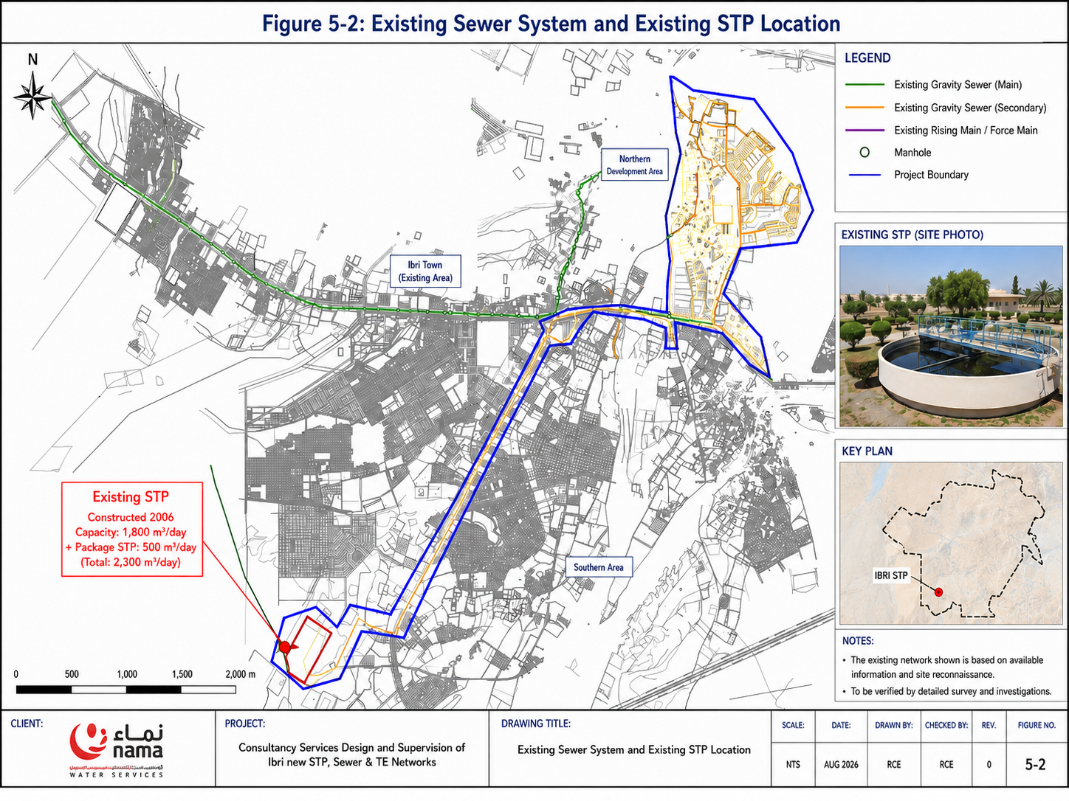
Figure 2 Existing Ibri Sewage Treatment Plant
  - Existing Sewer Network
The available information indicates that the existing sewer system serves a limited part of the overall Ibri project area and conveys wastewater towards the existing STP.
The existing network layout and asset information shall be verified through:
- collection and review of available as-built drawings and GIS data;
- field verification of manholes, pipelines and connections;
- confirmation of pipe diameters, materials, levels and flow directions;
- review of existing lifting or pumping facilities;
- identification of connected customers;
- review of blockage, surcharge, odour and maintenance records;
- CCTV inspection of selected critical sections; and
- assessment of the hydraulic and structural condition of the system.
The verified information will be used to determine which parts of the existing system can be retained, rehabilitated, upgraded or integrated into the proposed sewer network.

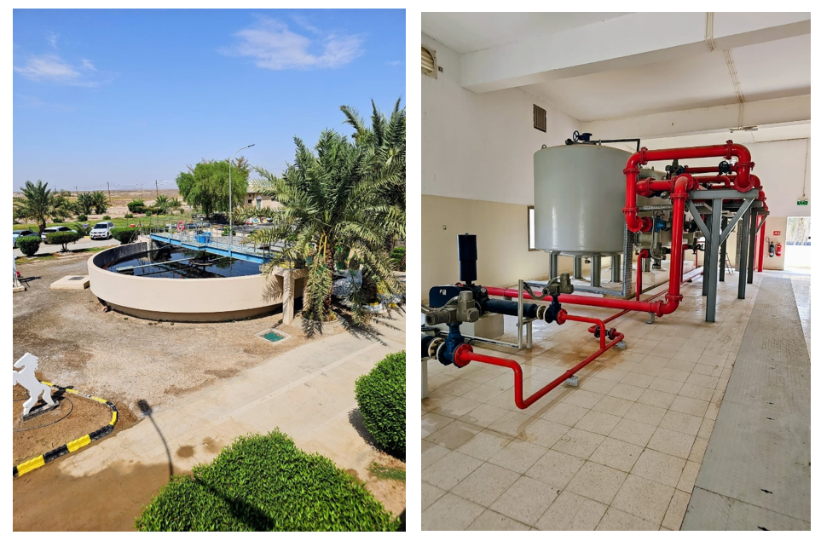
Figure 3 Existing Ibri Sewer Treatment Plant

  - Preliminary Findings
Based on the site visit and currently available information, the following preliminary findings have been identified:
- The combined nominal capacity of the existing STP and package plant is approximately 2,300 m³/day.
- The present total inflow is also approximately 2,300 m³/day.
- Approximately 48% of the current inflow is received from the sewer network.
- Approximately 52% of the current inflow is delivered by yellow tankers.
- The existing treatment facilities appear to have little or no spare treatment capacity.
- Future expansion of the sewer network will increase the direct sewered inflow to the STP.
- Yellow-tanker flows must be considered separately when determining the present and future treatment capacity.
- The condition and actual performance of the existing STP and package plant require confirmation through operational data and detailed assessment.
- The existing STP site may remain important as the terminal location for the future sewer system, subject to confirmation of its suitability for expansion.
- The existing sewer system requires full verification before it is included in the hydraulic model or future design.
All findings presented at this stage are preliminary and shall be confirmed through detailed data collection, field surveys, operational records, laboratory data and coordination with NWS operation and maintenance personnel.

- Design Basis and Applicable Standards
  - General Design Basis
The design shall be developed in accordance with the Contract requirements, approved project scope, NWS engineering standards and the requirements of the relevant authorities in the Sultanate of Oman.
The design basis will be progressively developed and confirmed during the concept, preliminary and detailed design stages. At the inception stage, the principal design basis includes:
- the approved project boundary;
- existing and future land use;
- existing developed, vacant and under-construction plots;
- population and development forecasts;
- existing water consumption and wastewater generation;
- existing sewer, STP and treated effluent infrastructure;
- topographical, geotechnical and groundwater conditions;
- wastewater quantity and characteristics;
- treated effluent demand and reuse requirements;
- environmental, flood and wadi constraints;
- land availability for the STP, lifting stations and other facilities;
- utility corridors and authority requirements;
- operational reliability and maintenance requirements; and
- phased implementation in accordance with actual development.
All assumptions used during the early design stages shall be clearly identified and shall be updated when verified data becomes available.
  - Design Horizon
The planning and demand assessment for the project shall extend up to the year 2100, as instructed by NWS.
Population projections shall be developed using two independent methods:
- population estimation based on electricity account and consumption data; and
- population projections based on NCSI data.
The NCSI population forecast shall be adopted up to the year 2040. Beyond 2040, the population shall be projected up to 2100 using a justified linear growth method, unless updated official projections become available.
The population results from both methods shall be compared and reconciled. The adopted population forecast shall also be checked against:
- APSR planning and regulatory requirements;
- the approved master plan for the Ibri area;
- existing and planned land-use development;
- available housing and plot data;
- water-consumption records; and
- other relevant information provided by NWS and the concerned authorities.
Based on the adopted population forecast, wastewater generation and treated effluent demand shall be calculated up to 2100.
The collection system shall then be assessed to determine the year at which each major system component reaches its practical or hydraulic capacity. This assessment shall cover:
- secondary and trunk sewers;
- lifting stations;
- rising mains;
- the STP;
- treated effluent transmission and distribution facilities; and
- associated storage and pumping infrastructure.
The saturation year shall not be assumed in advance. It shall be established from the projected population, connection rate, wastewater generation, network development and actual capacity of each system component.
The resulting saturation and capacity-trigger years shall form the basis of the project phasing and financial model. The financial assessment shall identify:
- the timing of each investment phase;
- required capacity at each stage;
- expected connection and demand growth;
- capital expenditure by phase;
- operating expenditure;
- replacement and expansion requirements;
- whole-life cost; and
- the most appropriate implementation strategy up to 2100.
The adopted design horizons for individual assets may therefore differ depending on their capacity, useful life and expansion requirements, while the overall planning framework shall remain based on the year 2100.

  - Population and Wastewater Flow Basis
Population and wastewater generation shall be assessed separately for each village and planning area within the project boundary.
The population forecast shall be developed using:
- NCSI population projections up to 2040;
- justified linear projections from 2040 to 2100;
- electricity-account data;
- plot and land-use information; and
- the approved master plan and APSR planning requirements.
The results from the different methods shall be compared and reconciled before adoption for design. The preliminary population projections are presented below.

Table 2- Preliminary Population Projection by Village
No. | Village / Area | 2030 | 2040 | 2050 | 2060 | 2070 | 2080 | 2090 | 2100
1 | Ad Dariz | 9,186 | 14,136 | 17,310 | 24,516 | 34,530 | 43,773 | 55,488 | 70,340
2 | Ad Dibayshi | 1,869 | 2,876 | 3,522 | 4,988 | 7,025 | 8,906 | 11,289 | 14,311
3 | Al Akheedar | 153 | 236 | 289 | 409 | 576 | 731 | 926 | 1,174
4 | Al Araqi | 8,292 | 12,759 | 15,624 | 22,128 | 31,168 | 39,510 | 50,085 | 63,490
5 | Al Aynayn | 3,531 | 5,433 | 6,653 | 9,422 | 13,271 | 16,823 | 21,325 | 27,033
6 | Al Ghubayrah | 490 | 753 | 922 | 1,306 | 1,840 | 2,333 | 2,957 | 3,748
7 | Al Jahli | 321 | 495 | 606 | 858 | 1,208 | 1,532 | 1,942 | 2,461
8 | Al Jibayyah | 2,082 | 3,204 | 3,923 | 5,556 | 7,826 | 9,921 | 12,576 | 15,942
9 | Al Makhtibyah | 94 | 145 | 178 | 252 | 355 | 450 | 571 | 724
10 | Al Qali | 148 | 228 | 279 | 395 | 556 | 705 | 894 | 1,133
11 | Al Qurayn | 425 | 654 | 801 | 1,135 | 1,598 | 2,026 | 2,569 | 3,256
12 | Al Wahrah | 2,598 | 3,998 | 4,895 | 6,933 | 9,765 | 12,379 | 15,692 | 19,892
13 | Ash Shiab | 36 | 56 | 69 | 97 | 137 | 173 | 220 | 279
14 | At Tayyib | 2,596 | 3,994 | 4,891 | 6,927 | 9,756 | 12,368 | 15,678 | 19,874
15 | Bat | 1,982 | 3,050 | 3,735 | 5,290 | 7,451 | 9,445 | 11,973 | 15,177
16 | Hijar | 801 | 1,232 | 1,509 | 2,137 | 3,010 | 3,816 | 4,838 | 6,132
17 | Ibri | 52,024 | 80,053 | 98,028 | 138,835 | 195,549 | 247,887 | 314,234 | 398,339
18 | Miayrid | 26 | 41 | 50 | 70 | 99 | 125 | 159 | 202
19 | Satwah | 204 | 313 | 384 | 544 | 766 | 971 | 1,230 | 1,560
20 | Sayh Al Masarrat | 361 | 555 | 680 | 963 | 1,357 | 1,720 | 2,180 | 2,764
21 | Shalashil | 101 | 155 | 190 | 269 | 378 | 480 | 608 | 771
22 | Suwayda Al Ma | 1,208 | 1,859 | 2,277 | 3,225 | 4,542 | 5,758 | 7,299 | 9,252
23 | Tanam | 1,641 | 2,524 | 3,091 | 4,378 | 6,167 | 7,817 | 9,909 | 12,562
24 | Usaybuq | 70 | 108 | 133 | 188 | 265 | 336 | 426 | 540
25 | Wadi Al Mankas | 40 | 62 | 76 | 107 | 151 | 192 | 243 | 308
 | Total Population | 90,280 | 138,920 | 170,115 | 240,928 | 339,348 | 430,175 | 545,311 | 691,264

Based on the adopted population forecast, wastewater generation shall be calculated using the applicable water-consumption rates, return factors, non-domestic contributions, infiltration allowances and NWS design criteria.

Table 3-Preliminary Wastewater Generation by Village
No. | Village / Area | WWG 2030 | WWG 2040 | WWG 2050 | WWG 2060 | WWG 2070 | WWG 2080 | WWG 2090 | WWG 2100
1 | Ad Dariz | 2,329 | 3,443 | 4,158 | 5,781 | 8,036 | 10,117 | 12,756 | 16,100
2 | Ad Dibayshi | 474 | 701 | 846 | 1,176 | 1,635 | 2,058 | 2,595 | 3,276
3 | Al Akheedar | 39 | 57 | 69 | 97 | 134 | 169 | 213 | 269
4 | Al Araqi | 2,102 | 3,108 | 3,753 | 5,218 | 7,253 | 9,132 | 11,513 | 14,532
5 | Al Aynayn | 895 | 1,323 | 1,598 | 2,222 | 3,088 | 3,888 | 4,902 | 6,188
6 | Al Ghubayrah | 124 | 183 | 222 | 308 | 428 | 539 | 680 | 858
7 | Al Jahli | 81 | 120 | 145 | 202 | 281 | 354 | 446 | 563
8 | Al Jibayyah | 528 | 780 | 942 | 1,310 | 1,821 | 2,293 | 2,891 | 3,649
9 | Al Makhtibyah | 24 | 35 | 43 | 59 | 83 | 104 | 131 | 166
10 | Al Qali | 38 | 55 | 67 | 93 | 129 | 163 | 205 | 259
11 | Al Qurayn | 108 | 159 | 192 | 268 | 372 | 468 | 590 | 745
12 | Al Wahrah | 659 | 974 | 1,176 | 1,635 | 2,273 | 2,861 | 3,607 | 4,553
13 | Ash Shiab | 9 | 14 | 16 | 23 | 32 | 40 | 51 | 64
14 | At Tayyib | 658 | 973 | 1,175 | 1,633 | 2,271 | 2,859 | 3,604 | 4,549
15 | Bat | 502 | 743 | 897 | 1,247 | 1,734 | 2,183 | 2,752 | 3,474
16 | Hijar | 180 | 278 | 340 | 481 | 678 | 859 | 1,089 | 1,381
17 | Ibri | 11,716 | 18,028 | 22,076 | 31,265 | 44,037 | 55,823 | 70,765 | 89,705
18 | Miayrid | 6 | 9 | 11 | 16 | 22 | 28 | 36 | 45
19 | Satwah | 46 | 71 | 86 | 122 | 172 | 219 | 277 | 351
20 | Sayh Al Masarrat | 81 | 125 | 153 | 217 | 306 | 387 | 491 | 622
21 | Shalashil | 23 | 35 | 43 | 61 | 85 | 108 | 137 | 174
22 | Suwayda Al Ma | 272 | 419 | 513 | 726 | 1,023 | 1,297 | 1,644 | 2,084
23 | Tanam | 369 | 568 | 696 | 986 | 1,389 | 1,760 | 2,232 | 2,829
24 | Usaybuq | 16 | 24 | 30 | 42 | 60 | 76 | 96 | 122
25 | Wadi Al Mankas | 9 | 14 | 17 | 24 | 34 | 43 | 55 | 69
 | Total Wastewater Generation (m³/day) | 21,287 | 32,241 | 39,266 | 55,213 | 77,377 | 97,830 | 123,759 | 156,627

Ibri is the largest population and wastewater catchment throughout the planning period. The total projected population increases from approximately 90,280 in 2030 to approximately 691,264 in 2100, while the corresponding wastewater generation increases from approximately 21,287 m³/day to approximately 156,627 m³/day.
These projections shall be used to determine the saturation year of each catchment and to establish the required phasing of the sewer network, pumping facilities, STP and treated effluent system.
  - Wastewater Collection System
The wastewater collection system shall be designed to maximise gravity conveyance and minimise pumping, while maintaining reasonable sewer depths and constructability.
The design shall consider:
- property and house connections;
- rider and lateral sewers;
- secondary and trunk sewers;
- existing network integration;
- sewer gradients and self-cleansing requirements;
- minimum and maximum velocities;
- proportional flow depth;
- minimum cover and maximum practical excavation depth;
- manhole spacing and access;
- groundwater and dewatering;
- corrosion and H₂S risks;
- road, utility, falaj and wadi crossings;
- trenchless construction where required;
- rehabilitation of suitable existing assets; and
- future network extension.
Gravity sewer hydraulic calculations shall be undertaken using approved hydraulic methods and licensed modelling software.
  - Sewage Lifting Stations and Rising Mains
Sewage lifting stations shall be introduced only where gravity conveyance is not technically or economically practical.
The design basis shall include:
- average and peak incoming flows;
- wet-well operating volumes;
- pump duty and standby requirements;
- minimum pump run time;
- maximum number of starts;
- emergency storage;
- standby power;
- overflow and emergency arrangements;
- odour and H₂S control;
- access and lifting facilities;
- reliability and maintainability;
- force-main velocity and retention time;
- air-release and washout arrangements;
- surge assessment; and
- SCADA monitoring and control.
Alternative routing or consolidation of catchments shall be assessed before confirming any lifting-station location.
  - Sewage Treatment Plant
The STP design shall be based on the confirmed influent flows, pollutant loads, required treated effluent quality and phased treatment capacity.
The process assessment shall consider:
- average and peak hydraulic loads;
- influent BOD, COD, suspended solids and nutrient concentrations;
- variations caused by yellow-tanker discharge;
- required Class A treated effluent quality;
- process reliability and redundancy;
- available land;
- energy consumption;
- chemical consumption;
- sludge production and handling;
- odour control;
- process flexibility;
- future expansion;
- ease of operation and maintenance;
- environmental impacts;
- whole-life cost; and
- compatibility with the existing STP facilities.
A minimum of three process or development alternatives shall be assessed during the concept stage before recommending the preferred solution.
  - Treated Effluent System
The treated effluent system shall be designed based on verified existing, potential and future customer demands.
The design shall consider:
- treated effluent production;
- daily and seasonal demand patterns;
- existing and future users;
- transmission and distribution mains;
- pumping requirements;
- storage and balancing requirements;
- minimum and maximum pressures;
- water quality protection;
- network zoning;
- tanker filling facilities;
- excess treated effluent management;
- emergency discharge provisions;
- hydraulic modelling; and
- future expansion.
The treated effluent network shall be clearly separated from potable-water infrastructure and shall include the required identification, protection and cross-connection control measures.
  - Hydraulic Modelling
The wastewater network shall be modelled using SewerGEMS, while the treated effluent system shall be modelled using WaterGEMS or other software approved by NWS.
The models shall be developed using:
- verified GIS and survey information;
- existing asset data;
- population and demand allocation;
- design flows;
- ground and invert levels;
- pipe characteristics;
- pump curves and operating controls;
- existing and proposed system configurations; and
- phased development scenarios.
The models shall be submitted in native editable format together with calculation sheets, assumptions and supporting reports.
  - Applicable NWS Documents
The principal NWS design guidelines applicable to the project are:
- PAM-GUD-201 – General Design Guidelines;
- PAM-GUD-202 – Potable Water and Treated Sewage Effluent Design Guidelines; and
- PAM-GUD-203 – Wastewater Design Guidelines.
These guidelines shall be used together with the applicable NWS:
- pipe and fitting specifications;
- valve and accessory specifications;
- civil-work specifications;
- mechanical specifications;
- electrical specifications;
- instrumentation, control and automation specifications;
- standard drawings;
- GIS and as-built requirements;
- commissioning procedures;
- asset handover procedures; and
- other project-specific instructions.
The latest approved revision available at the commencement of the relevant design activity shall be applied.
  - Other Applicable Standards and Regulations
Where a subject is not fully covered by the NWS standards, the design shall refer to appropriate recognised international standards, subject to NWS approval.
These may include relevant:
- British Standards and BS EN standards;
- European standards;
- ISO standards;
- IEC standards;
- NFPA requirements;
- AWWA standards;
- ASTM standards;
- structural concrete and steel design standards;
- equipment manufacturer standards; and
- internationally recognised wastewater and treatment-process design practices.
The project shall also comply with applicable requirements of:
- Nama Water Services;
- Authority for Public Services Regulation;
- Environment Authority;
- Ministry of Agriculture, Fisheries and Water Resources;
- Ministry of Housing and Urban Planning;
- Ministry of Transport, Communications and Information Technology;
- Civil Aviation Authority, where applicable;
- Civil Defence and Ambulance Authority;
- electricity and telecommunications authorities;
- Royal Oman Police;
- municipalities; and
- other relevant utility and regulatory bodies.

- Mobilisation Activities
During mobilisation, the Consultant shall establish the project team, confirm the scope and commence the main data collection and coordination activities.
The key mobilisation activities include:
- confirmation of the project organisation and responsibilities;
- review of available project documents and existing information;
- preparation of the detailed work programme and deliverable schedule;
- identification of required data from NWS and other authorities;
- mobilisation of survey and investigation teams;
- establishment of document control, communication and reporting procedures; and
- preparation of the project quality, HSE and design risk plans.
The mobilisation stage shall conclude with agreement on the immediate priorities, outstanding information and planned activities for the concept design stage.

- Data Collection and Validation
The Consultant shall collect and review all available information required for the design, including:
- existing sewer, STP and treated effluent drawings and GIS data;
- population, electricity account and NCSI information;
- water consumption and wastewater flow records;
- STP inflow, tanker discharge and treatment performance data;
- land-use, master plan and development information;
- utility, flood, geotechnical and environmental data; and
- applicable NWS standards and authority requirements.
All information shall be checked for completeness, consistency and reliability. Missing, conflicting or unverified data shall be recorded in a data-gap register and raised with NWS.
- Surveys and Field Investigations
The required surveys and investigations shall be mobilised to establish a reliable design basis. These activities include:
- topographical survey;
- verification of existing sewer and treated effluent assets;
- manhole and chamber inspections;
- CCTV survey where required;
- underground utility detection;
- trial pits at critical locations;
- geotechnical and groundwater investigations;
- inspection of the existing STP; and
- assessment of potential STP, lifting station and pipeline locations.
Survey results shall be incorporated into the project GIS and used for hydraulic modelling and design development.
- Stakeholder, NOC and Authority Coordination
The Consultant shall identify all relevant stakeholders and authorities and prepare a coordination and approval register.
Early coordination shall be initiated with:
- NWS departments and operation teams;
- APSR;
- MoHUP;
- MoAFWR;
- Environment Authority;
- road and transport authorities;
- electricity, telecommunications and other utility providers; and
- other concerned government entities.
The register shall identify required data, approvals, NOCs, responsible parties, submission dates and current status.
- Deliverables and Submission Strategy
Project deliverables shall be prepared in accordance with the Contract, approved programme and NWS requirements.
Each submission shall include, as applicable:
- reports and calculation documents;
- drawings and layouts;
- hydraulic models;
- GIS and database files;
- cost estimates and bills of quantities;
- design risk and option assessment records; and
- editable native files.
All deliverables shall undergo internal discipline checks and coordinated quality review before submission. Comments received from NWS shall be recorded, addressed and incorporated into the subsequent revision.
- Project Programme
The project programme has been prepared based on the durations stated in the Tender Document, with the commencement date taken as 2 August 2026.
The total design and tender-document period is 365 calendar days, including four NWS review periods of 21 calendar days each. The design-stage completion date is therefore 1 August 2027.

Activity | Duration | Start Date | Finish Date
Concept Design | 60 days | 2 August 2026 | 30 September 2026
NWS Review – Concept Design | 21 days | 1 October 2026 | 21 October 2026
Preliminary Design | 70 days | 22 October 2026 | 30 December 2026
NWS Review – Preliminary Design | 21 days | 31 December 2026 | 20 January 2027
Detailed Design | 90 days | 21 January 2027 | 20 April 2027
NWS Review – Detailed Design | 21 days | 21 April 2027 | 11 May 2027
Tender Documents Preparation | 61 days | 12 May 2027 | 11 July 2027
NWS Review – Tender Documents | 21 days | 12 July 2027 | 1 August 2027
Table 4 Project Activity Schedule
  - Concept Design Stage
The concept design stage will include:
- data collection and validation;
- topographical survey and field investigations;
- assessment of the existing sewer, STP and treated effluent systems;
- population and demand projections up to 2100;
- wastewater-generation and TSE-demand calculations;
- preparation of as-built and GIS information;
- development of sewer, TSE and STP alternatives;
- hydraulic modelling;
- preliminary cost and lifecycle-cost assessment;
- STP location and phasing assessment; and
- concept design workshop and submission.
  - Preliminary Design Stage
Following approval of the concept design, the preliminary design will develop the selected option and include:
- updated hydraulic models;
- preliminary network layouts and profiles;
- sizing of pipelines, lifting stations and related facilities;
- preliminary STP design, where instructed;
- surge, H₂S and odour assessments;
- preliminary civil, structural, mechanical, electrical and ICA design;
- HAZOP and value-engineering activities;
- preliminary BOQ and cost estimate; and
- NOC and land-coordination activities.
  - Detailed Design Stage
The detailed design stage will include:
- final hydraulic modelling and calculations;
- detailed sewer and TSE layouts and profiles;
- house-connection design;
- detailed pumping-station and rising-main design;
- final surge and odour-control design;
- coordinated civil, structural, mechanical, electrical and ICA design;
- final drawings, specifications and BOQ;
- cost estimate;
- authority and NOC requirements; and
- detailed design workshop and submission.
  - Tender Documents Stage
Following approval of the detailed design, the Consultant will prepare the construction tender documents, including:
- contractual and technical documentation;
- approved drawings;
- specifications;
- bills of quantities;
- schedules and data sheets;
- testing and commissioning requirements;
- contractor design and submission requirements; and
- final pre-tender cost estimate.
The programme will be updated regularly to reflect actual progress, receipt of required information, NWS instructions, authority approvals and any approved changes to the project scope.

- Project Organization and Team Arrangement
The project will be managed by the Project / Design Manager, supported by the Deputy Project Manager / Design Coordinator and the respective discipline leads.
The core project team will be based in Oman and will be responsible for the day-to-day execution of the assignment, including:
- coordination with NWS and local authorities;
- collection and validation of project data;
- site visits and field investigations;
- preparation of design calculations, models, drawings and reports;
- coordination between the sewer, treated effluent, STP and supporting disciplines;
- management of surveys, NOCs and stakeholder requirements; and
- preparation and submission of project deliverables.
The Oman-based team will include specialists covering project management, sewer and treated effluent network design, hydraulic modelling, STP process design, civil and structural engineering, mechanical, electrical, instrumentation and control, hydrology, geotechnical engineering, environment, GIS, surveying, cost estimation, contracts, NOC coordination, architecture and BIM/CAD services.
  - JV Project Coordination
The JV Project Coordinator will support communication and coordination between the JV partners and the Oman-based project team. The coordinator will assist in:
- arranging technical reviews;
- monitoring outstanding actions;
- coordinating submissions for JV review;
- following up discipline comments; and
- maintaining effective communication between the Oman and Korea teams.
  - JV Quality Control Team
The JV Quality Control Team will be based in Korea and will provide independent technical review and specialist support to the main design disciplines.
The Korea-based team will review key submissions and provide comments on:
- sewer network planning and hydraulic design;
- treated effluent network design;
- STP planning and process requirements;
- design criteria and assumptions;
- hydraulic calculations and modelling results;
- major technical options;
- constructability and operational considerations; and
- compliance with the project scope and applicable standards.
The quality-control review will be carried out at the main project stages, including concept, preliminary and detailed design, before formal submission to NWS.
  - Discipline Coordination
Each discipline lead will be responsible for the technical preparation and checking of their respective work. All discipline outputs will be coordinated through the Deputy Project Manager / Design Coordinator before review by the Project / Design Manager.
The project will therefore operate through:
- an Oman-based execution and coordination team;
- a Korea-based JV quality-control and specialist-support team; and
- regular coordination meetings between both teams.
This arrangement will provide local project presence, direct coordination with NWS and authorities, and additional independent quality review from the JV partner.

  - Project Team Contact List
No. | Team / Role | Designation | Name | Mobile No. | E-mail
1 | Project Management | Project / Design Manager | Hossein Forouzan | 72207112 | forouzan@renardet.net
2 | Project Management | Deputy Project Manager / Design Coordinator | Jaida Al Hinai | 94363030 | alhinai@renardet.net
3 | Network Design | Senior Sewer Network Hydraulic Engineer | Mojtaba Keivanluo | 92970635 | keivanlou@renardet.net
4 | Network Design | Senior Treated Effluent Network Hydraulic Engineer | Mehrdad Hadizadeh | 9218 3345 | hadizadeh@renardet.net
5 | Network Design | Hydraulic Modelling Engineer – SewerGEMS | Umesh Mane | 9583904 | mane@renardet.net
6 | Network Design | Hydraulic Modelling Engineer – WaterGEMS | Abolfazl Salemi | 91475346 | salemi@renardet.net
7 | STP Design | STP Process Design Engineer | Mehdi Safaiefar | 9130 3173 | safaiefar@renardet.net
8 | Hydrology | Hydrologist / Flood Protection Specialist | Nenad Nenadic | 95526210 | nenadic@renardet.net
9 | Mechanical | Mechanical Design Engineer | Mahesh Kumar | 91464365 | mahesh@renardet.net
10 | Electrical | Electrical Design Engineer | Karthikeyan A.K. | 76861551 | karthikeyan@renardet.net
11 | ICA | Instrumentation, Control and Automation Engineer | Ravi Kumar | 91282560 | ravi@renardet.net
12 | Civil / Structural | Civil / Structural Design Engineer | Masood Dashti | 74162197 | dashti@renardet.net
13 | Geotechnical | Geotechnical Engineer | Christian Mocellin | 9898341 | mocellin@renardet.net
14 | Environmental | Environmental Engineer / EIA Specialist | Zahra Allahdad | 91238206 | zahra@renardet.net
15 | GIS | GIS Specialist / Asset Data Engineer | Faseeh Fawad | 96483252 | fawad@renardet.net
16 | Survey | Topographical Survey Engineer | Marco Munna | 91432616 | munna@renardet.net
17 | Commercial | Quantity Surveyor / Cost Engineer | Raja Ahmet | 95912837 | raja@renardet.net
18 | Contracts | Contract and Tender Specialist | Mohammed Nedal Chams Idden | 99548037 | nedal@renardet.net
19 | NOC Coordination | NOC and Authority Coordination Engineer | Nasser Al Rawahi | 99214629 | nasser@renardet.net
20 | Infrastructure | Road, Wadi and Utility Crossing Engineer | Darko | 91912476 | darko@renardet.net
21 | Architecture | Architectural and Landscaping Engineer | Taha Rafi Ahmed | 94657115 | taha@renardet.net
22 | BIM / CAD | BIM / CAD Coordinator | Hirosh | 99845062 | perera@renardet.net
23 | BIM / CAD | CAD Draftsman – Civil / Structural / MEP | Mihilal Ranathunga | 95873541 | mihilal@renardet.net
24 | JV Coordination | JV Project Coordinator | Ara Jang | +82 6323 3327 | arajang@dohwa.co.kr
25 | JV Quality Control | Senior Principal Engineer – Water & Sewerage | Kiseok Lee | +82 2 6323 3461 | solidify@dohwa.co.kr
26 | JV Quality Control | Senior Principal Engineer – Water & Sewerage | Seunghyun Kang | +82 2 6323 3415 | ksh0522@dohwa.co.kr
27 | JV Quality Control | Senior Water & Sewerage Engineer | Andrew Kavuma | +82 2 6323 3523 | akavuma1@dohwa.co.kr
Table 5 Project Team Contact List

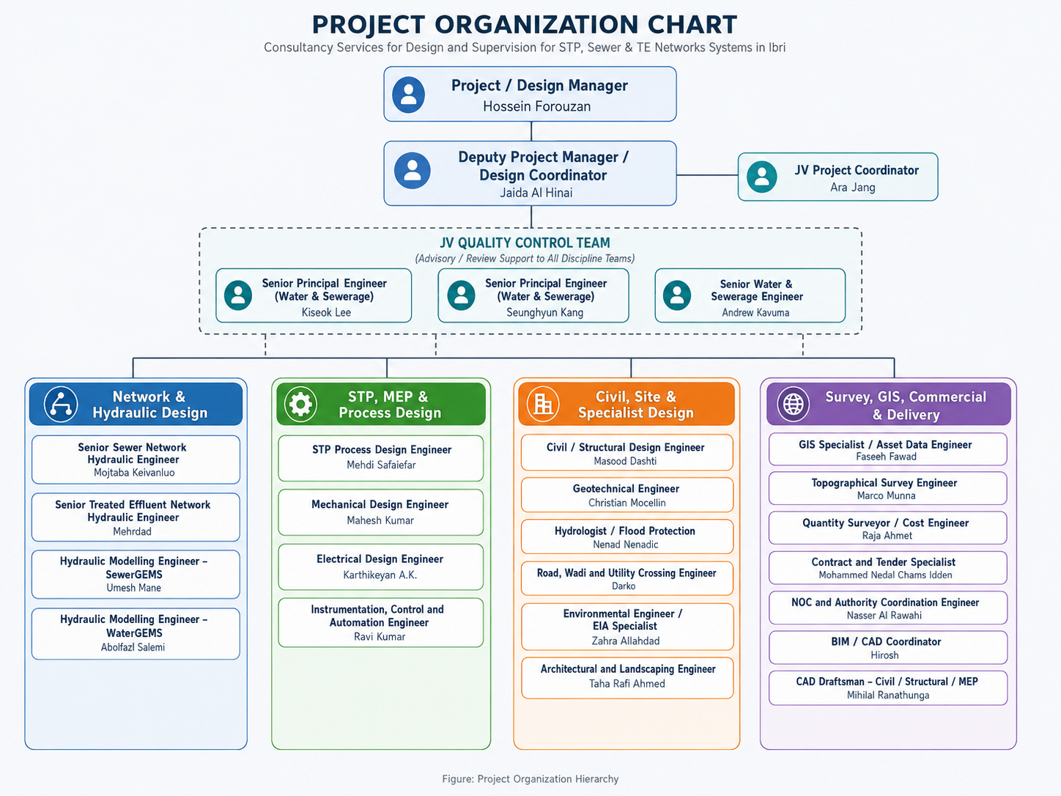
Figure 4 Project Organization Chart

- HSE Requirements & Plan
- Health and Safety Requirements (Design Phase)
- Risk Identification in Design: Identify potential health and safety risks related to the design, such as site-specific hazards or safety-critical aspects of the project.
- Compliance with HSE Regulations: Ensure all designs comply with local health, safety, and environmental regulations.
- Design for Safety: Incorporate safety features into the design, such as safe access, emergency exits, and fire protection systems.
- Client and Stakeholder Coordination: Coordinate with the client and stakeholders to ensure that HSE requirements are considered and integrated into the design.
- HSE Documentation: Maintain clear documentation of all HSE-related aspects of the design, including risk assessments and safety features.
- HSE Plan Execution (Design Phase)
- HSE Review in Design Process: Implement regular HSE reviews during design stages to ensure all safety and environmental considerations are addressed.
- Regulatory Compliance Checks: Ensure that the design complies with all health and safety regulations and environmental requirements through internal checks and approvals.
- Risk Mitigation in Design: Propose and implement design solutions that mitigate identified risks, such as safe material handling, ergonomic considerations, and hazard control measures.
- Stakeholder HSE Requirements: Incorporate any specific HSE requirements provided by the client or regulatory bodies into the design process.
- Continuous Improvement (Design Phase)
- HSE Audits: Conduct regular internal audits to ensure that HSE requirements are integrated into the design and that risks are minimized.
- Team Awareness and Training: Ensure the design team is trained and aware of the importance of incorporating HSE aspects into their work.
- Feedback and Learning: Use feedback from HSE audits, client reviews, and lessons learned from past projects to improve safety and environmental aspects in future designs
- Quality Requirements & Plan
- Quality Requirements (Design Phase)
- Compliance with Design Standards: Ensure that all designs follow relevant local and international standards.
- Accuracy of Design: Ensure precision in calculations, modeling, and design to avoid errors in later construction phases.
- Material and Equipment Specifications: Specify materials and equipment that meet the project and regulatory requirements.
- Design Reviews and Approvals: Regular internal design reviews and client approvals at key stages to ensure compliance and alignment with project goals.
- Documentation and Reporting: Maintain comprehensive and clear documentation of all design processes, decisions, and revisions.
- Quality Plan Execution (Design Phase)
- Design Quality Control Procedures: Implement quality control checks at each stage of the design to ensure accuracy and compliance with specifications.
- Review and Sign-Off Process: Set up a structured review and approval process for all design submissions, ensuring client involvement.
- Non-Conformance Reporting (NCR): Track any issues or deviations from the design standards and resolve them promptly.
- Coordination with Stakeholders: Ensure effective coordination with the client, local authorities, and other stakeholders for feedback and approvals.
- Design Verification: Conduct internal reviews and verification of all designs to ensure they meet project requirements.
- Continuous Improvement (Design Phase)
- Design Audits: Carry out periodic internal audits to ensure that design practices adhere to quality standards.
- Team Training: Provide training and development for the design team to maintain high standards of performance and awareness of latest best practices.
- Feedback Loop: Use feedback from the client and internal audits to improve design processes and avoid repeat issues in future projects.

- Scope of Work for Topographic, Existing Utility Survey and GIS Data Collection
  - Existing Utility Survey and Detailed Topographic Survey (Approx. 20 km²):
Survey and mapping of the existing wastewater infrastructure, including Wastewater (WW) networks, Sewage Treatment Plants (STPs), Treated Effluent (TE) networks, and all associated above-ground and underground assets. The scope includes a detailed topographic survey, collection of Original Ground Levels (OGL), utility asset attributes, and preparation of GIS-ready asset inventory datasets in accordance with Nama Water Services GIS Standards. The preparation of the GIS database is included in the survey scope; however, integration into the Nama Water GIS Database and obtaining final approval from Nama Water Services shall remain the responsibility of the Contractor.
  - Detailed Topographic Survey (Approx. 450 km²)
Comprehensive topographic survey covering the entire project area, including approximately 20 km² of existing wastewater infrastructure. The survey shall include all visible above-ground features, utilities, buildings, roads, wadis, fences, vegetation, and terrain data with Original Ground Levels (OGL) collected at 5–10 m intervals, depending on terrain conditions.
The Contractor shall perform all survey works in accordance with the latest Nama Water Services (NWS) GIS Data Specifications, the Oman National Spatial Reference Framework (ONSRF), National Survey Authority (NSA) survey standards, applicable engineering and GIS standards, Health, Safety and Environmental (HSE) requirements, and all relevant authority regulations. All survey data shall be collected using approved high-accuracy survey methodologies and delivered in the formats specified by the Consultant and NWS.
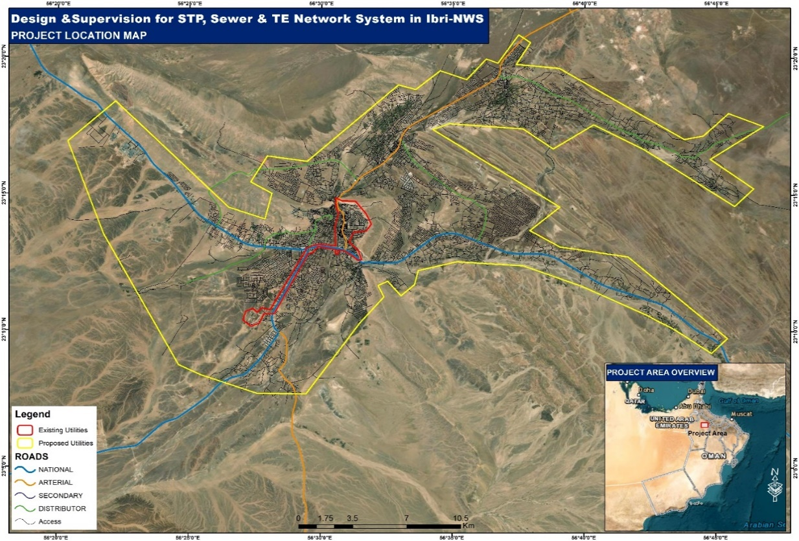
Figure 5 Project Location Map
  - Objectives
The survey shall provide:
- Accurate horizontal and vertical position of all assets.
- Complete topographical information.
- Existing underground utility locations.
- Detailed GIS asset inventory Integrated with NAMA GIS database.
- Utility connectivity information.
- As built drawing in CAD and GIS.

  - Scope of Work (SoW) Project – 1
    - Existing Utilities Field Data Collection and GIS integration
The Contractor shall undertake a comprehensive field survey to collect the location, elevations, dimensions, attributes, and condition of all existing assets within the STP, WW, and TE networks. The survey shall be carried out using high-accuracy DGPS connected to the nearest National Survey Authority (NSA) benchmark, supplemented by Total Station and Digital Level where required. All data shall be referenced to the approved national coordinate system (UTM Zone 40N, WGS 84) and comply with the Client's GIS Data Specifications.
    - Wastewater (WW) / Sewer System
The Contractor shall carry out a detailed field survey of the existing Wastewater (WW) network and associated assets in accordance with the Nama Water Services (NWS) GIS Data Specification. Using high-accuracy DGPS connected to the nearest NSA benchmark, the Contractor shall collect the precise location, elevations, dimensions, pipe information, connectivity, condition, and all required GIS attributes. Manholes and chambers shall also include cover and invert levels, chamber dimensions, and geo-referenced photographs. All data shall be submitted in the approved GIS and CAD formats. NAMA GIS database layers mentioned below.
Layer Name | Description
wwCASING | Wastewater Casing
wwCHAMBER | Wastewater Chamber
wwCROSS_SERVICE | Wastewater Cross Service
wwFITTINGS_N_JOINTS | Wastewater Fittings and Joints
wwFLOWMETER | Wastewater Flow Meter
wwForceLine | Wastewater Force Line
wwINSPECTIONPIPE | Wastewater Inspection Pipe
wwManhole | Wastewater Manhole
wwMARKERPOST | Wastewater Marker Post
wwPUMP | Wastewater Pump
wwPUMPINGSTATION | Wastewater Pumping Station
wwSewerLine | Wastewater Sewer Line
wwVacuumSewerLine | Wastewater Vacuum Sewer Line
wwVALVE | Wastewater Valve
wwVENTPIPE | Wastewater Vent Pipe
wwVMC | Wastewater Valve Meter Chamber
wwVMC_JOINT | Wastewater Valve Meter Chamber Joint
wwWaterAccount | Wastewater Water Account
Table 6 GIS Database Layers - WW

    - Treated Effluent (TE)
The Contractor shall carry out a detailed field survey of the existing Treated Effluent (TE) network and associated assets in accordance with the Nama Water Services (NWS) GIS Data Specification. Using high-accuracy DGPS connected to the nearest NSA benchmark, the Contractor shall collect the precise location, elevations, dimensions, pipeline information, connectivity, condition, and all required GIS attributes. Chambers and other applicable TE assets shall also include cover and invert levels, dimensions, and geo-referenced photographs where applicable. All data shall be submitted in the approved GIS and CAD formats. NAMA GIS database layers mentioned below.
Layer Name | Description
teCASING | Treated Effluent Casing
teCHAMBER | Treated Effluent Chamber
teCROSS_SERVICE | Treated Effluent Cross Service
teExMonitoringDevice | Treated Effluent External Monitoring Device
teFITTINGS_N_JOINTS | Treated Effluent Fittings and Joints
teFLOWMETER | Treated Effluent Flow Meter
teFutureConnection | Treated Effluent Future Connection
teLine | Treated Effluent Line
teMARKERPOST | Treated Effluent Marker Post
tePUMP | Treated Effluent Pump
tePUMPINGSTATION | Treated Effluent Pumping Station
teRESERVOIR | Treated Effluent Reservoir
teTHRUSTBLOCK | Treated Effluent Thrust Block
teVALVE | Treated Effluent Valve
Table 7 GIS database layers - TE
    - Sewage Treatment Plant (STP)
The Contractor shall carry out a detailed field survey of the existing Sewage Treatment Plant (STP) and all associated assets in accordance with the Nama Water Services (NWS) GIS Data Specification. Using high-accuracy DGPS connected to the nearest NSA benchmark, the Contractor shall collect the precise location, elevations, dimensions, condition, and all required GIS attributes for each asset. Buildings, tanks, chambers, pipelines, roads, equipment, electrical and instrumentation assets, and other STP facilities shall be surveyed, and geo-referenced photographs shall be captured where applicable. All data shall be submitted in the approved GIS and CAD formats. GIS and CAD formats. NAMA GIS database layers mention below.
Layer Name | Description
stp_BUILDING | Sewage Treatment Plant Building
stp_CHAMBER | Sewage Treatment Plant Chamber
stp_pcManhole | Sewage Treatment Plant Process Control Manhole
stp_E_POLE | Sewage Treatment Plant Electrical Pole
stp_EARTH_PITS | Sewage Treatment Plant Earth Pits
stp_EARTHING_SYSTEM | Sewage Treatment Plant Earthing System
stp_ELETRICITY_LINE | Sewage Treatment Plant Electricity Line
stp_EQUIPMENT | Sewage Treatment Plant Equipment
stp_FENCE | Sewage Treatment Plant Fence
stp_FIRE_HYDRANTS | Sewage Treatment Plant Fire Hydrants
stp_FITTING | Sewage Treatment Plant Fitting
stp_FO_Line | Sewage Treatment Plant Fiber Optic Line
stp_FOChamber | Sewage Treatment Plant Fiber Optic Chamber
stp_INSTRUMENT | Sewage Treatment Plant Instrument
stp_KVA6_JOINTS | Sewage Treatment Plant 6 kVA Electrical Joints
stp_LANDSCAPE_AREA | Sewage Treatment Plant Landscape Area
stp_LANDSCAPE_POINT | Sewage Treatment Plant Landscape Point
stp_MANHOLE | Sewage Treatment Plant Manhole
stp_PIPELINE | Sewage Treatment Plant Pipeline
stp_PIPELINE_EXTERNAL | Sewage Treatment Plant External Pipeline
stp_PUMP | Sewage Treatment Plant Pump
stp_ROAD | Sewage Treatment Plant Road
stp_SCREEN | Sewage Treatment Plant Screen
stp_SEWER_LINE | Sewage Treatment Plant Sewer Line
stp_STORAGE_LAGOONS | Sewage Treatment Plant Storage Lagoons
stp_STORAGE_TANK | Sewage Treatment Plant Storage Tank
stp_TE_LINE | Sewage Treatment Plant Treated Effluent Line
stp_THRUST_BLOCK | Sewage Treatment Plant Thrust Block
stp_VALVE | Sewage Treatment Plant Valve
stpBOUNDARY | Sewage Treatment Plant Boundary
Table 8 GIS database layers - STP
  - Scope of Work (SoW) Project – 2
    - Detailed Topographic Survey
The Contractor shall carry out a detailed topographical survey of the project area using appropriate survey methodologies, including high-accuracy DGPS/GNSS, Total Station, conventional surveying techniques, mobile mapping, and UAV photogrammetry were considered appropriate. The selection of the survey methodology shall be at the Contractor's discretion, provided that all specified survey requirements and deliverables are achieved.
The topographical survey shall include the collection of Original Ground Levels (OGL) at a maximum spacing of 5 to 1o meters, with additional spot levels collected wherever necessary to accurately represent changes in terrain, embankments, slopes, drainage features, and other significant topographic variations.
The survey shall capture all visible surface features required for engineering design, planning, and construction. This shall include, but not be limited to, road centerlines, carriageway edges, kerbs, medians, footpaths, pavements, road markings (where applicable), traffic islands, roundabouts, road signs, guardrails, street lighting, utility poles, overhead utility lines, buildings, boundary walls, fences, gates, bridges, culverts, drainage channels, catch pits, manholes, wadis, retaining walls, embankments, cut and fill slopes, open spaces, water bodies, vegetation, trees, significant landscape features, and all other permanent or temporary features that may influence the proposed design.
The survey shall also include the collection of sufficient spot levels and break lines to accurately represent the existing ground surface, road profiles, drainage patterns, changes in terrain, and other critical topographic characteristics necessary for detailed engineering design and hydraulic analysis.
All existing underground and above-ground utility assets shall be surveyed and positioned using appropriate high-accuracy survey methods referenced to the National Survey Authority (NSA) control network. Utility surveys shall accurately capture the location and attributes of all accessible assets, including pipelines, manholes, chambers, valves, pumping stations, and other associated infrastructure. Mobile mapping and UAV-derived data may be used to supplement the survey; however, they shall not be used as the primary source for determining the final coordinates of utility assets.
The Contractor shall deliver all survey outputs, including topographic mapping, DEM, DTM, DSM (where applicable), orthophotos (where aerial surveys are undertaken), CAD drawings, GIS-ready datasets, and all associated survey deliverables in accordance with the latest Nama Water Services GIS Data Specifications, the Consultant's requirements, and applicable national surveying standards.
The topographical survey shall include, but not be limited to, the following feature classes:

